

TEACHING CASE – PART 3 BUSINESS PROCESS ANALYSIS AND SOLUTIONING

Banking and Insurance Domain

BPAS Team

Table of Contents

1.1 Objective 2

1.2 Team 2

1.3 Submission 2

1.4 Timeline 2

1.5 Task 2

2. Performance Goals 6

2.1 Performance goals and metrics 6

3. Modeling and Simulation Preparations 6

3.1 Simulation Data Parameters 6

3.2 Analysis Techniques 7

4. AS-IS PROCESS – MODELING and SIMULATION 7

4.1 As-Is process dynamic analysis - Summary 7

5. To-Be Process - Modeling and Simulation 8

5.1 Preparation of to-be scenarios 8

5.2 To-be Model dynamic analysis - Summary 9

6. Impact Analysis 9

6.1 To-be Model Impact Analysis - Summary 9

6.2 Final Selected To-be Process Performance Summary 11

7. FINAL SELECTED To-be PROCESS MODELS 11

7.1 To-Be Resource Model 11

7.2 To-Be Collaboration Model 12

7.3 To-Be Workflow Model with Recommendations 13

8. APPENDIX A: AS-iS ANALYIS 14

9. APPENDIX B - COMPARISON ANALYSIS 15

10. Appendix C: FINAL Selected To-Be Workflow Model 16

## 1.1 Objective

To understand the approach for the dynamic analysis for both as-is and to-be process. To understand the approach to select the analysis techniques, prepare to-be scenarios and analyzing both simulation results as well as internal and external impact. Apply the concepts of process performance goals and impact analysis for the model in the given MIPS process.

## 1.2 Team

This exercise is to be completed in project teams.

|  |  |
| --- | --- |
| ***Team Number:***  ***T_*** | ***Team Members***  ***1. Jolene Teah***  ***2. Kelly Chan***  ***3. Bryan Tay***  ***4. Zen Tan***  ***5. Wei Minn***  ***6. Chen Yibing*** |

## 1.3 Submission

Complete the tasks (as stated on page 3 to page 5) and submit to e-learn.

## 1.4 Timeline

|  |  |
| --- | --- |
| Approximate time to complete task | 1 hrs |
| Start time | Week 5 |
| End time | Week 6 (1 day before class – 23:59) |

## 1.5 Task

Read the case and get familiar with:

1. Preparations for the dynamic simulations for MIPS claims process
2. As-Is process dynamic analysis summary.
3. To-be modelling using the recommendations proposed in as-is static analysis stage.
4. Impact analysis of various to-be scenarios
5. To-be models; Collaboration model and workflow model

Complete and submit the following activities (from page 3 to page 5):

1. Fill in the metrics in the following process performance goals table:

|  |  |  |
| --- | --- | --- |
| **S.No** | **Performance Goals** | **Metrics** |
| 1 | Reduce the average waiting time for a claims request by at least 25%. | Average waiting time |
| 2 | Reduce the “overall cost” for a claims process by at least 10% | Overall cost |
| 3 | Remove the bottlenecks that have been identified by 30% | Bottle neck |
| 4 | Reduce manual activity by 40% | Manual activity |
| 5 | (Create new goal) |  |

1. What is impact of the following recommendations?

Note: Refer to Table 4 for more details on the recommendations and analysis.

|  |  |
| --- | --- |
| **Recommendations** | **Impact Analysis** |
| **Collaboration with medical institutions** to streamline the insurance claim process. | **External Impact**  Information on patients is regarded as confidential and this recommendation will have serious implication with privacy issues and host of other government regulation and institutional policies. |
| HQCOs to undergo **training** to help with the checking of fraudulent claims. | **Internal Impact**  HQCOs need to put into extra hours or dedicate a portion of their working hours to the training on vetting through the claims for fraud. |
| Implement **self-service kiosks** at the branch for claimers to enter claim details and scan supporting documents which will be recorded electronically. | **Internal Impact**  A few manpower needs to be allocated to supervise over the kiosks and help customers with the process just like they did in with self-check-in machines in the airport.  **External Impact**  Claimants need to be made aware of the user interface and the available functionalities of the kiosks. |
| Implement **claim management mobile app** for claimers to enter claim details and scan supporting documents which will be recorded electronically. | **Internal Impact**  Resources need to be allocated to   * Maintain and improve the mobile app * Gives customer support on technical issues and functionality   **External Impact**  Just like with Kiosks, Claimants need to be made aware of the user interface and the available functionalities of the mobile app. |
| Claim payments can be done via **direct bank transfer**. | **Internal Impact**  The Payment officers need to adopt new procedures when they integrate direct bank transfer with cheque payments. |

1. Fill up the type of analysis technique that can be performed to answer the given process analysis question.

|  |  |  |
| --- | --- | --- |
| **S.No** | **Question** | **Analysis Technique** |
| 1. | How many claims are processed per day? | Capacity analysis |
| 2. | How much is the BCSO utilized? | Resource utilization |
| 3. | What if I add another BCSO? | Possible scenarios |
| 4. | What is the average time to check policy validations? | activity time |
| 5. | What is the average cycle time to server each customer? | Process cycle time |
| 6. | Which activities are holding up the process? | Bottle neck analysis |
| 7. | Which activities take too long? | Bottle neck analysis |
| 8. | Which path is most common? | Path analysis |
| 9. | What is the average cost to check for fraud? | Process cycle time |

# PERFORMANCE GOALS

## Performance goals and metrics

Based on the wish list and the static analysis, the following performance goals and metrics are set for the to-be process.

|  |  |
| --- | --- |
| **Performance Goals** | **Metrics** |
| Reduce the average waiting time for a claims request by at least 25%. | Average waiting time |
| Reduce the “overall cost” for a claims process by at least 10% | Overall cost |
| Remove the bottlenecks that have been identified by 30% | Bottle neck |
| Reduce manual activity by 40% | Manual activity |

Table 1: Process Performance Goals

# MODELING AND SIMULATION PREPARATIONS

## Simulation Data Parameters

In this section, we describe the type of the data available for the simulation of the as-is and tobe process.

|  |  |
| --- | --- |
| **Data Type** | **Description** |
| Simulation start time | The branch opens everyday at 830 and closes at 530. We chose 830, Monday as simulation start time. |
| Arrival rate | Arrival rate of the claimants can be random. For the simulation, we fixed it to 30 minutes. |
| Currency | The currency used in the costing is USD. |
| No of instances | The instance triggers the process and multiple instances (claimants) are expected in one day. For this project, we set 180 instances in 10 days. |
| No of resources for human role | For human roles, we have set fixed numbers taken from the interview scripts. For the machines, we set to 100. |
| Resources’ timetable | We create the time table based on the interview scripts for all the resources. |
| Decision points  probabilities | For as-is process, the probabilities are taken from the interview scripts. For to-be process since we shifted some of the activities, reasonable assumptions are made on the decision points. |
| Future capacity | To study the efficiency of the chosen to-be process, we set the future capacity to 300 instances in 10 days. |
| Resource cost | For human roles, we have set fixed numbers taken from the interview scripts and for the machines, we set to 0(unlimited) |

Table 2: Dynamic Simulation Parameters and examples

## Analysis Techniques

In this section, we describe the analysis techniques suitable for our project. The choice of analysis techniques depend on the type of simulation data available to us.

|  |  |
| --- | --- |
| **Analysis technique** | **Description** |
| Capacity analysis | We are provided with the future capacity speculations on the number of claims MOB will receive in the two years time. Hence, we will study the performance of our to-be based on the future needs as well. |
| Activity cost/time analysis | For all the activities in the process, we have collected the time taken. Activities are associated with the resources and we have the cost of all resources. This enables us to perform cost and time analysis for each activity. |
| Bottleneck analysis | Activity time and number of resources together with multiple instances per day, enable us to study the bottlenecks in the process. |
| Resource  utilization analysis | The resource timetable and activity time enable us to study the resource utilization. |
| Path analysis | We have 5 paths in as-is, 4 rejected paths and 1 approved path. We shall perform the path analysis to study the cost and time improvements in all the paths. |
| Process time and cost | Overall cost and time of the process is studied to align with the performance goals set in the section 3.1. |
| What-if analysis | With various recommendations proposed and some overlaps such as having kiosk and mobile app for claims submission. Therefore, we will create various to-be scenarios and study the impact. Various to-be scenarios enable us to perform what-if analysis on the to-be models. |

Table 3: Dynamic simulation analysis techniques

# AS-IS PROCESS – MODELING AND SIMULATION

## As-Is process dynamic analysis - Summary

Based on the data provided by the business users, we have performed simulations on the asis process. To run 180 instances of claim applications, the process takes an average of 1.3 weeks and average cost of USD 47.

In our detailed analysis, the most occurring path is where HQCM has successfully approved the claim. Since the most occurring path's average elapsed duration and average total cost do not deviate much from the weighted average, we can deduce that any changes made to this would have the greatest impact on the optimization of the claims process. We have also observed that the rejection paths, “rejections at HQ due to insufficient documents” and “rejections due to invalid claims” are most expensive rejections paths of all the rejection paths. Therefore, we focus on maximizing benefit for the success path by optimizing the cost and time factors. At the same time, we will also focus on reducing the wastage on the rejection paths.

The bottleneck analysis in the simulation indicated few tasks that slow down the entire process. For example, “BCSO update CES with payment cheque collection date and close claim request case” and “HQCO check for claimants insurance validity and coverage type using PAS” are two top activities where the average delay duration is more than 55 minutes. The resource utilization analysis shows that the BCSO is occupied around 60% of the time in the process and this indicates the increase in the average delay for the bottleneck analysis.

Based on the above as-is analysis, we move to the solution space to review the recommendations proposed in the static analysis. The as-is analysis also provides a platform for us to re-define the process performance goals and compare the efficiency of the proposed to-be process with as-is dynamic simulation results.

# TO-BE PROCESS - MODELING AND SIMULATION

## Preparation of to-be scenarios

Given the recommendations short-listed from static analysis, we propose the following To-Be scenarios that consider the combinations of recommendations to handle various components on the workflow model; submission, verifications, approvals, rejections and notifications. At the same time, the to-be scenarios are chosen by considering the impact on the issues depicted in RCI model. In the table below, we only show the recommendation numbers. Please refer the Teaching Case - PART2 for the details of the recommendations.

Note that recommendations, 1, 3, 4, 5, 6 and 7 are commonly used in all the scenarios. These recommendations are crucial to tackle root causes such as paper bases process, validations, notifications and data analytics for fraud and optimise the business process. The remaining recommendations, 8, 9, 10 and 11 are ideas that can provide benefits to the process. We will study them in the what-if scenario analysis together with its complexity. Although mobile app for claims submission, recommendation 10, has better performance compared to kiosk, the complexity of the documents for claim submission leads to implementation and operation challenges. Therefore, for most to-be scenarios, we did not consider the mobile app option.

|  |  |  |
| --- | --- | --- |
| **Scenario** | **Recommendations** | **Brief details** |
| To-be 1 | 1, 3, 4, 5, 6, 7, 9 | Kiosk is chosen as the channel of the claim submission. We don’t implement any external party integrations in this scenario. |
| To-be 2 | 1, 3, 4, 5, 6, 7,10 | Mobile app is chosen as the medium for new claim submission. We don’t implement any external party integrations in this scenario. |
| To-be 3 | 1, 3, 4, 5, 6, 7, 9, 11 | Kiosk is chosen as the channel of the claim submission. We implement bank transfer integration in this scenario. |
| To-be 4 | 1, 3, 4, 5, 8, 7, 8, 9,  11 | Kiosk is chosen as the channel of the claim submission. We implement bank transfer integration in this scenario. We also suggest internal policy change that HQCO can perform the fraud detection activities in the process. |
| To-be 5 | 1, 2, 3, 4, 5, 6, 7, 8, 9 | Kiosk is chosen as the channel of the claim submission. We implement external parties (hospitals, police services) integration in this scenario. We also suggest |
|  |  | internal policy change that HQCO can perform the fraud detection activities in the process. |
| To-be 6 | 1, 2, 3, 4, 5, 6, 7, 8, 9,  11 | Kiosk is chosen as the channel of the claim submission. We implement external parties (bank, hospitals, police services) integration in this scenario. We also suggest internal policy change that HQCO can perform the fraud detection activities in the process. |

Table 4: To-be what-if scenarios derived from the recommendations

## To-be Model dynamic analysis - Summary

In this section, we provide the summary of the to-be analysis together with the process performance goals set in Section 2.1. As we will be focusing on the chosen to-be process in this document, the details of the other to-be models is skipped to reduce the confusion.

After the simulations and dynamic analysis, we observed that the To-be6 has best performance and at the same time enables innovative ideas of using analytics in the project. The next best performance is to-be5, to-be4 and to-be3 in decreasing order. The optimized results for last three models are very close to each other. Dynamic analysis data results details has been omitted in the case study. Summary description of the dynamic analysis is as below.

Cost Savings: Firstly, new online web application (CMPotral) and integrations of the systems Claims Accounting System (CAS) and Claims Adjustment System (CAJ), streamline the claims process into a common platform that is accessible by MOB’s staff and customers. By removing isolated updates to each individual system, a centralized system ensures single truth of the data and improves the quality of the process. This will also remove the need of having courier services to deliver claim documents as these documents will be transmitted through systems electronically saving the cost on courier and dispatch services.

Time savings: Having an integrated insurance claims web portal between bank and MOB will remove additional time for the cheque preparations and saves both claimants as well as staff’s time. Activities like creating new claim request in Clains Entry System (CES) and photocopying of documents will be removed from the process as it will be done automatically by CMPortal. Furthermore, the implementation of the CMPortal website would allow claimants to view their claim status in real time and also upload claim documents via the website. This would greatly reduce the time that BCSOs spend in handling difficult calls and redirect extra time to activities that value add to the process. In addition, the use of fraud analytics engine by HQCOs to detect fraudulent claim cases will allow MOB to improve the fraud detection decision-making process more evidence based and efficient.

# IMPACT ANALYSIS

## To-be Model Impact Analysis - Summary

The dynamic analysis on all to-be scenarios gave detailed figures and the alignment with the performance goals. The comparisons from previous sections also provided the evidences to study the performances of all the to-be models. However, to the make the final decision, we discussed with the project sponsors on the impact analysis. Table below shows the impact analysis of all the to-be what-if scenarios.

|  |  |
| --- | --- |
| **To-be**  **Scenario** | **Impact Analysis** |
| To-be 1 | No external impact  The scenario majorly focusses on the automation using the internal systems and reducing manual documentation by introducing the kiosk web application and system integration. Internal impact is expected to be minimum as the Kiosk is a wellestablished technology. |
| To-be 2 | External impact in terms of customers  The scenario majorly focusses on the automation using the internal systems and reducing manual documentation by introducing the mobile app web application and system integration. In scenarios where the mobile network is down or the users are not extensive users of the mobile apps, or lack of understanding on supporting document, MOB has to provide additional random support. This indirectly creates an internal impact as well. |
| To-be 3 | External impact  The scenario majorly focusses on the automation using the internal systems and reducing manual documentation by introducing the kiosk web application and system integration. At the same time, the integration with the banks for the claim amount transfer to the claimants. The integration of systems with the bank systems requires to open a bank account for claim transfers. However, since MOB already has bank account for their administration, this should be direct process. |
| To-be 4 | External impact and internal impact.  The scenario majorly focusses on the automation using the internal systems and reducing manual documentation by introducing the kiosk web application, internal systems integration, bank system integration and HQCO policy changes. On top of the external bank impact, the current internal policy of only HQCM should perform fraud detection should be amended. This might have significant implication internally in the organisation. |
| To-be 5 | External impact and internal impact.  The scenario majorly focusses on the automation using the internal systems and reducing manual documentation by introducing the kiosk web application, internal systems integration, hospital and police system integration and HQCO policy changes. On top of the internal impact by HQCO policy changes, integration with the external partners creates a significant amount of impact. There might be impact of the government polices as well since the hospital data is confidential. Overall, this scenario create significant impact both internally and externally. . |

|  |  |
| --- | --- |
| To-be 6 | External impact and internal impact.  The scenario majorly focusses on the automation using the internal systems and reducing manual documentation by introducing the kiosk web application, internal systems integration, bank integration, hospital and police system integration and HQCO policy changes. On top of the internal impact by HQCO policy changes, integration with the external partners creates a significant amount of impact. Overall, this scenario create highest impact both internally and externally when compared to other scenarios. |

Table 5: Impact analysis of to-be scenarios

Since the internal and external impact on the to-be6, to-be5 and to-be4 is high, project sponsors and the team chose To-be3 scenario for the final implementation. The remaining sections of this case use To-be3 process model in the solution design. Please refer to section 7 for the detailed collaboration and workflow model.

## Final Selected To-be Process Performance Summary

In this section, we present the efficiency of the chosen to-be process in terms on the process performance goals.

1. Reduced Average Cycle Time - Average cycle time is reduced by 98.67% from 2581.6 minutes in the As-Is model to 34.1 minutes in To-Be 3 model. This meant that now it takes only an average of 34.1 minutes to complete one claim request, which is a huge improvement.
2. Bottlenecks - All manual tasks causing the major bottlenecks are eliminated in the To-Be 3 Model, hence all major bottlenecks are completely removed.
3. Reduced Cost - Average cost is reduced by 78.41% from $38.16 in the As-Is model to $8.24 in the To-Be 3 model. This meant it costs MOB $8.24 to handle one claim request, which is a great improvement from the As-Is process.
4. Manual tasks – Manual tasks such as dispatch, customer notifications, and cheque processing are either removed are automated with the introduction of technology.

Overall, we believe that the chosen to-be process, To-be3, will enhance the MOB's value of customer service and reputation. We also predict that there would be a higher system adoption rate by the claimants for the proposed to-be process for the following reasons.

A paper conducted by Labucay, I.D (2011) on the Internet use in the Philippines revealed only 2% of rural households have Internet access. However, 72% of the non-internet users were found to ask others to use the Internet for them. Although there is substantial evidence that the rural citizens possess the capacity to use the online portal, juxtaposed with the automated SMS system in To-Be 3, the SMS system will clearly be adopted. This is because we can expect a near 100% of claimers accepting a SMS approach for notifications. This is justified as firstly, mobile penetration rate in the Philippines is 105% and is set to increase (Budde.com.au, 2014). Secondly, most rural farmers possess a mobile phone that they use for mobile banking (On mobile banking services in Philippines: YouTube, 2014; Chemonics International Inc, 2014). Therefore, by riding on the bandwagon of mobile services via SMS mainly for notifications, it is highly expected that the claimers would easily adopt the new SMS system, thereby increasing the feasibility of To-Be 3. However, since the claims submission has complex rules as mentioned, we shall not use the mobile app for the claims submission task. In future, the company can consider the mobile app in future if the documentation is simplified.

# FINAL SELECTED TO-BE PROCESS MODELS

## To-Be Resource Model

Based on chosen to-be3 scenario, the key changes in the resource model compared to As-IS are, the introduction of CMPortal, Kiosk and the Bank accounts payable system and the removal of the CES system. For human roles, the courier and the dispatch units are no longer required in the to-be process.

Figure 1

:

To

-

be

Resource

Model

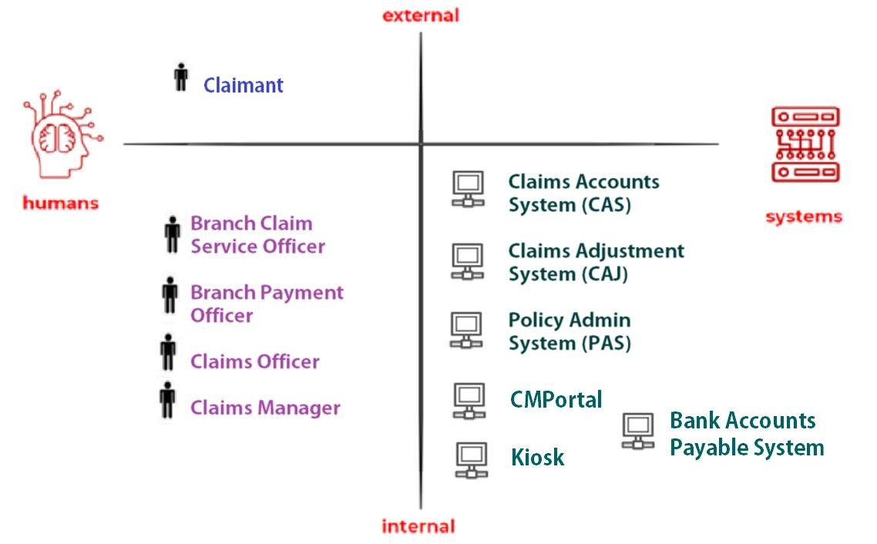

## To-Be Collaboration Model

Figure 2 shows the to-be collaboration model for the chosen to-be process.

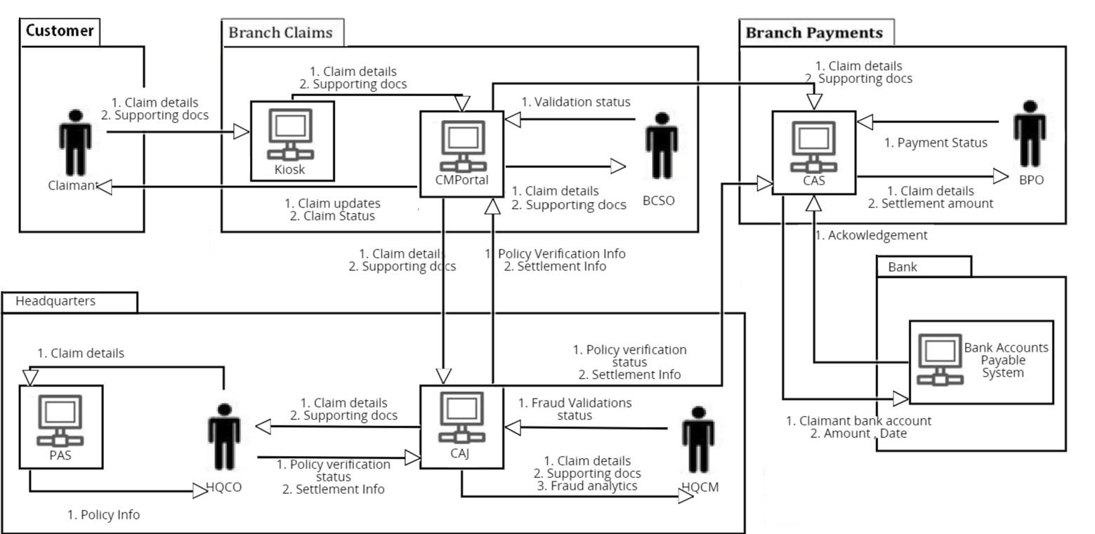

Figure 2: To-be Collaboration Model

## To-Be Workflow Model with Recommendations

To-be workflow is derived from the recommendations proposed in RCR stage and the final recommendations for to-be3 are depicted in Table 4. Figure 3 shows the recommendations implemented in various sections of to-be3 process workflow model. Appendix C shows the tobe workflow model without the masking of recommendations.

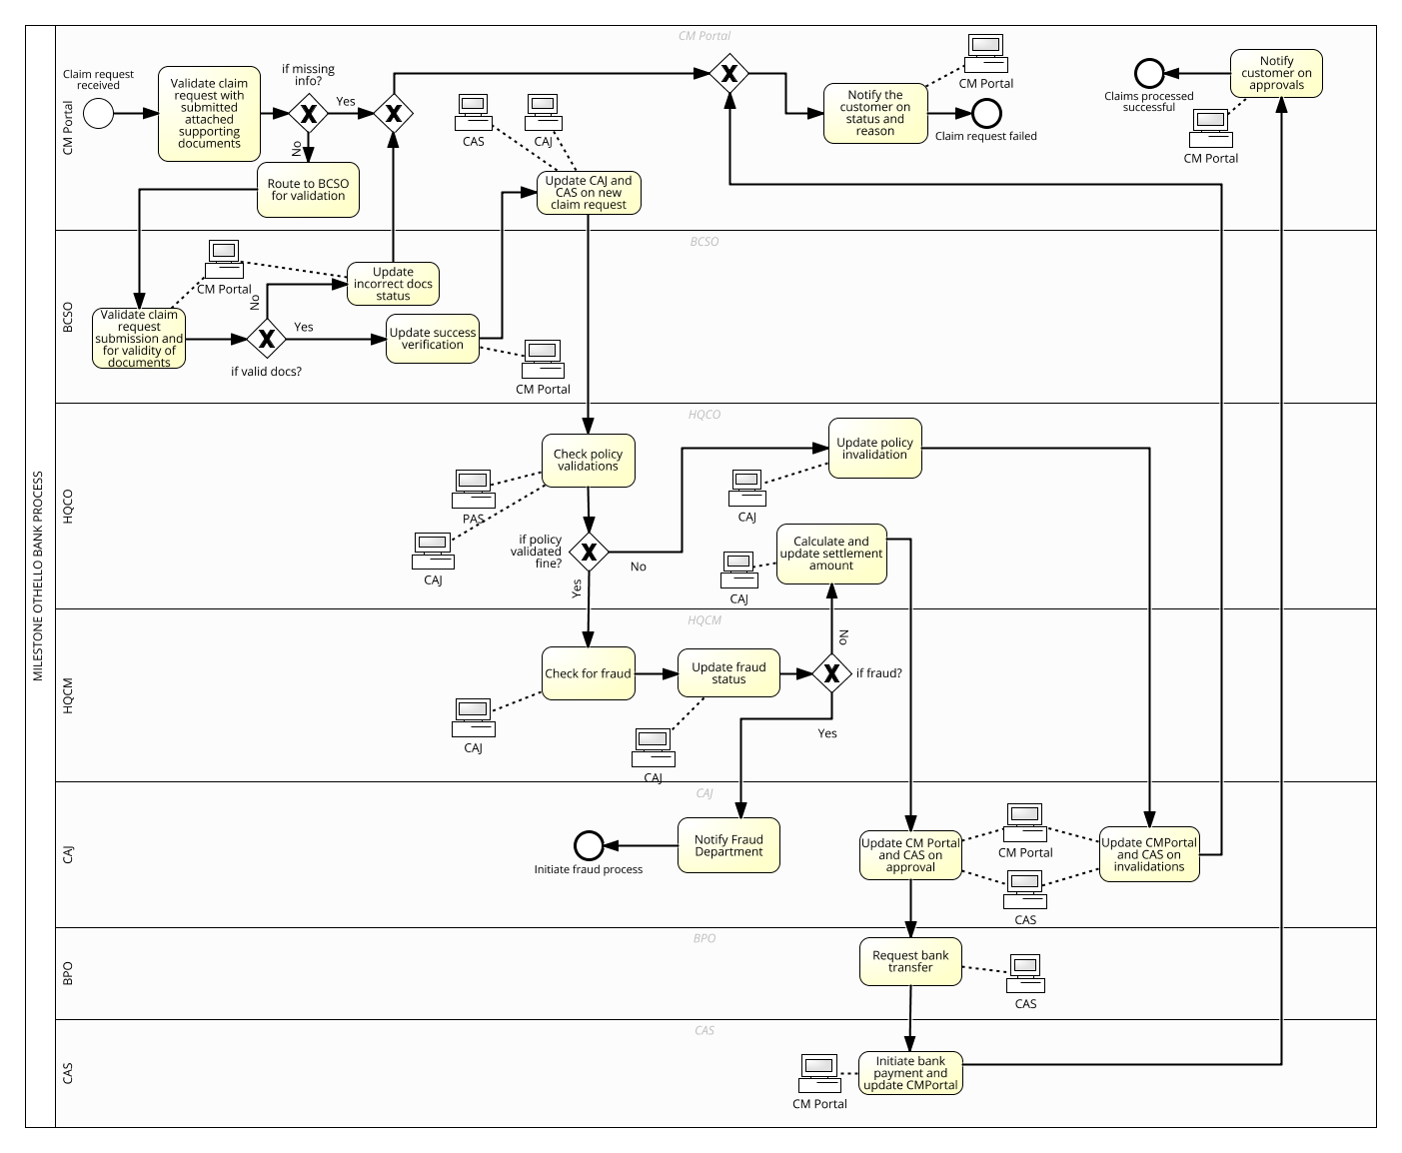

New Claims Management

Recommendations; 1, 4, 8



Notifications

Recommendations; 6



Payment

Recommendations; 11



Fraud Verifications

Recommendations; 7, 9



Policy Verifications

Recommendations; 3

Figure 3: To-be workflow model with overview of recommendations

# APPENDIX A: AS-IS ANALYIS

Path Analysis Report:

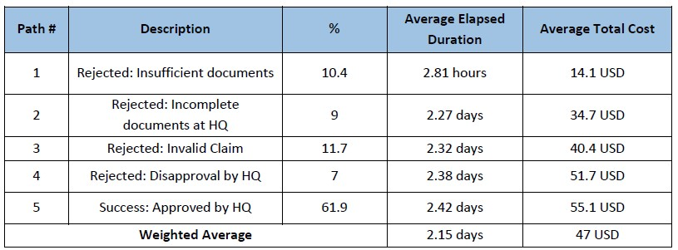

The above report indicates that paths #1, #2, #3 and #4 are paths that result in rejection of customer claims due to insufficient documents, incomplete documents, invalidity and disapproval by HQ respectively. The time and resources (cost) spent on these 4 paths are overheads or wastages that should be minimized or even eliminated. The most occurring path is path #5 where the claim has been successfully approved by HQ. Since the most occurring path's average elapsed duration and average total cost do not deviate much from the weighted average shown, we can deduce that any changes made to path #5 would have the greatest impact on the claims process.

Bottleneck Analysis Report:

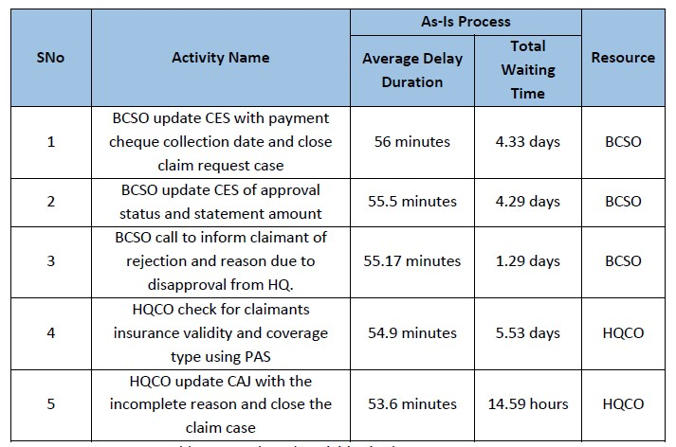

The report shows top 5 activities that have the highest average delay duration. BCSOs are also involved in the top 3 activities with the highest average delay duration. Hence, we can deduce that there is a high dependency on BCSOs in the claims process. At the same time, the limited number of BCSOs has resulted in a longer waiting time.

# APPENDIX B - COMPARISON ANALYSIS

1. To-be 1 and To-be 3

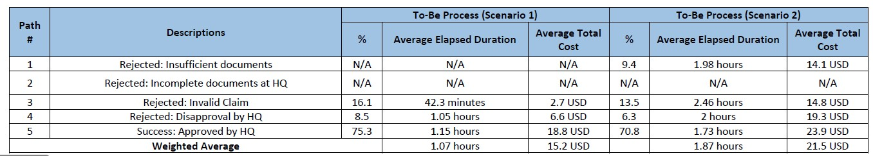

To-be1 is better than To-be 3 both in terms of the average elapsed duration and the average total cost. Therefore, we will use To-be 3 for further analysis and comparison against the As-Is process.

1. To-be 3 and As-is analysis

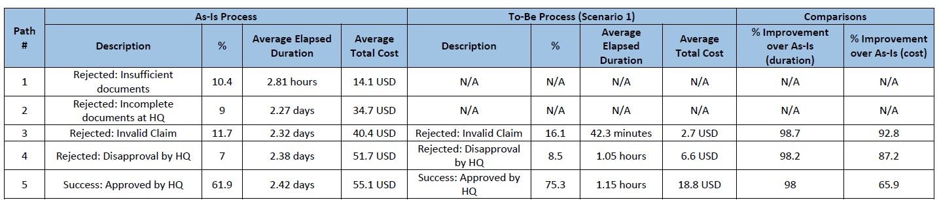

We observe that the To-Be Process (To-be 3) has significant improvements over the As-is process in terms of the average elapsed duration as well as the average total cost. Overall, there is visible improvement in all the paths of the claims process. With reference to above table, the most occurring path is path #5 where the claim has been successfully approved by the HQ. It has an improvement of 98% and 65.9% in the average elapsed duration and average total cost respectively. In addition, the average elapsed duration for path #5 is only 1.15 hours, which means all of the claims request can be completed within the day or next.

# APPENDIX C: FINAL SELECTED TO-BE WORKFLOW MODEL

